** SPACE AGENCY**

**(Nasa inspired)**

First: members’ names:

1 _ Mohab Mamdouh kamle mosa (Computer Science).

2 _ Youssef Wael Mostafa (Computer Science).

3 _ Karim Mamdouh Abd al Qader (Computer Science).

4 _ Ziad Mohammed Gomaa Youssef (Computer Science).

5 _ Ammar Elsaied Mohammed (computer Science).



Second: supervisor name:

* _ professor/Wael Zakaria.

* _ professor/mohammed hashim.

//File contents(double click to open):

1_team members name.txt. 5_relational model.pdf.

  

2_data inputs. Excel. 6_creation_SQL file.

 

3_project_presentation. 7_SQL queries file.

  

4_EER.pdf. 8_SQL model.mwb.

 



**Third: DESCRIPTION OF PROBLEM:**

**The Space Operations Mission Directorate:** is a crucial part of NASA’s operations. This directorate is responsible for maintaining a continuous human presence in space, which benefits people on Earth in numerous ways, from advancing scientific knowledge to developing new technologies.

 The programs within this directorate are at the heart of NASA’s human space exploration efforts. They enable various missions, including Artemis, commercial space initiatives, scientific research, and other agency missions.

The directorate provides a range of services to support these missions. These include communication services, which ensure that data and information can be transmitted between Earth and spacecraft; launch services, which are responsible for getting spacecraft into space; and research capabilities, which allow NASA to conduct experiments and gather data in space.

In essence, the Space Operations Mission Directorate plays a vital role in making space exploration possible and advancing our understanding of the universe. It’s a testament to the incredible work that NASA does every day. 🚀

**REQUIREMENT COLLECTION:**

The agency needs to be aware of the specific details of space operations directorate for effective management and coordination:

**1.staff(astronaut,scientist,inspector………etc):**

citizen identification number, fname, mname ,lname,{home address}: building no., street name, postal code, city, state, country, phone number {up to 3 numbers},salary, birth date(age).

**-astronaut:**

education, experience, physical fitness (up to 10).

*-experience is the total years of working of the astronaut even outside of the current job.

__________________

**-scientist:**

specialty.

*-side detail:

age is needed to be calculated.

___________________________________________________

**2.crew details:**

(Crew ID, name, status, start date).

*-side detail:

Experience years is needed to be calculated.

___________________________________________________

**3.partners:**(organization code, organization name, address, email address, phone number).

**__________________________________________________**

**4.space craft:**

(spacecraftID,name,type/class{rover, space probe,crewedspacecraft,auto},launchpad,status{active,lost,retired}, Power Source(solar ,nuclear),dimensions {size and weight},people capacity, load capacity).

__________________________________________________

**5.planet:** PlanetID (primary key), Planet Name, Type (terrestrial or gas giant), Diameter, Mass, Orbit Radius, Orbit Period, Rotation Period, Number of Moons, and Has Rings.

___________________________________________________

**6.material:**  MaterialID (primary key), Material Name, Hardness, Brittleness, Flexibility, Impermeability, Transparency, Thermal Conductivity, and Heat Conduction.

___________________________________________________

**7.mission:** MissionID (primary key), Mission Name, Mission Type (e.g., Airborne Science, Analog Field Testing, Asteroid Deflection, Atmospheric Probe, Balloon, Commercial Crew, Commercial Resupply[), Status (e.g., active, future, past), and objective](https://www.nasa.gov/missions/).

___________________________________________________

**8.research:** research ID, name,type{e.g., Aeronautics, Space Environmental Effects, Renewable Energy and Building Energy Efficiency, Material Response Properties},findings, publications no.

**9.equipment (satellites, telescopes…………etc.):**

ID,name, Status:(e.g., active, decommissioned)., type, origin country

_______

**9_1. satellite(communication, analysis):**

Orbit Type {(e.g., geostationary, polar, low Earth)}, Purpose:{(e.g., Earth observation, scientific research, GPS)}.

**-analysis:** sensor type and resolution.

**9_2. telescope:**

focal length, diameter.

**-space-based:**

Orbit.

**-Earth-based:**

Mount-type, location.

**Type values of telescopes and mount type values:**

**\***Mount type {e.g.: altazimuth, equatorial, for earth-based telescopes}.

___________________________________________________

**RULES:**

**1.**planet contains at least one material or more and material can exist on several planets.

**2.**mission can target one planet, but it is not a must, and each planet might be explored with several missions.

**3.**research is around mission or other objectives and mission must have minimum one research as a result or more.

**4.**one spacecraft goes to several missions and at least one mission and can be crewed or not with tracking the launch date and end date.

**5.**the members of staff work in different fields including inspector, astronaut and scientist.

**6.**The crew is required to consist of a minimum of 4 astronauts and a maximum of 7 astronauts and every astronaut has to join only one crew.

7**.** A scientist, whether alone or in collaboration with others, could conduct research using a variety of equipment, although the use of equipments is not a necessity.

**8.**the agency has several equipment including satellite, telescopes……etc.

**9.**telescopes must split to two different types:

- space based

- earth based

**10.**satellites also must split to two different types:

- communication type

- analysis type

**11.**The communication satellite must be monitored with a group consists of a minimum of 2 inspectors and a maximum of 5 inspectors and every group has to monitor only one satellite of that type.

**12.**each communication satellite can connect with up to 5 spacecrafts (or none),and every spacecraft must have connection with one satellite.

**13.**telescope must be launched on spacecraft if it is of space type and spacecraft can launch with one telescope.

**14.**equipment might be operated with one partner.

**15.**The partner may supply machines, which are equipment and spacecrafts.

**16.**some partners participate in research with different fields.

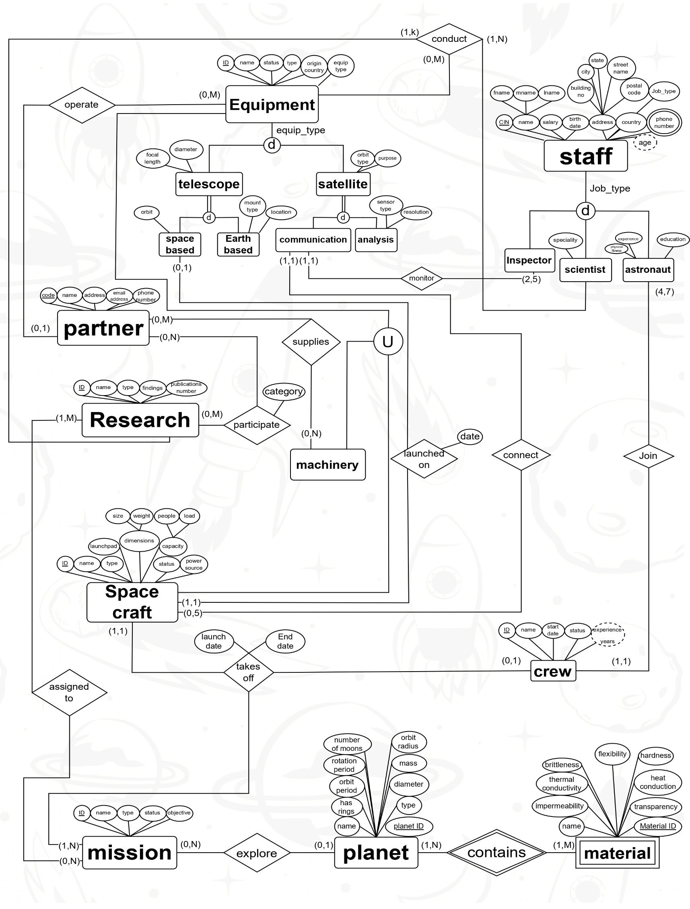

EER

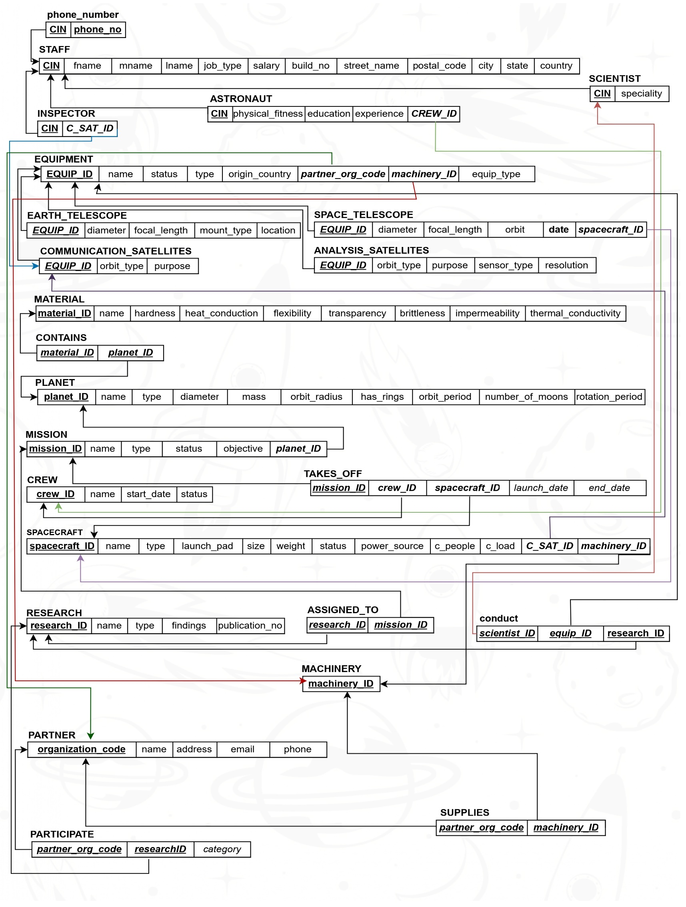

RELATIONAL MODEL

**RELATIONAL MODEL(2nd method)blue and italic for fk**

**PHONE_NUMBER :**(*CIN*, phone number)

**STAFF:**(CIN,fname,mname,lname,job_type,salary,build no,street name,postalcode,city,state,country).

**INSPECTOR:**(*CIN*,*C_SAT_ID*). **| SCIENTIST:**(*CIN*,speciality).

**ASTRONAUT:**(*CIN*,physical_fitness,education,experience,*CREW_ID*).

**EQUIPMENT:**(EQUIP_ID,name,status,type,origin_country,*PARTNER_ORG_CODE*,*MACHINERY_IDNN*,equip_type)

**EARTH_TELESCOPE:**(*EQUIP_ID*,diameter,focal_length,mount_type,location)

**SPACE_TELESCOPE:**(*EQUIP_ID*,diameter,focal_length,orbit,*date*,*SPACECRAFT_IDNN*)

**COMMUNICATION_SATELLITE:**(*EQUIP_ID*,orbit_type,purpose)

**ANALYSIS_SATELLITE:**(*EQUIP_ID*,orbit_type,purpose,sensor_type,resolution)

**MATERIAL:**(MATERIAL_ID,name,hardness,heat_conduction,flexibility,transparency,brittlness,impermeability,thermal_conductivity).

**CONTAINS:**(*MATERIAL_IDNN,PLANET_IDNN*)

**PLANET:**(PLANET_ID,name,type,diameter,mass,orbit_radius,has_rings,orbit_period,number_of_moons,rotation_period).

**MISSION:**(MISSION_ID,name,type,status,objective,*PLANET_ID*)

**CREW:**(CREW_ID,name,start_date,status).

**TAKES_OFF:**(MISSION_IDNN,*CREW_ID*,*SPACECRAFT_IDNN*,*launch_date,end_date*)

**SPACECRAFT:**(SPACECRAFT_ID,name,type,launch_pad,size,weight,status,power_source,c_people,c_load,*C_SAT_IDNN*,*MACHINERY_IDNN*).

**RESEARCH:**(RESEARCH_ID,name,type,findings,publications_no)

**ASSIGNED_TO:**(RESEARCH_IDNN,MISSION_IDNN)

**CONDUCT:**(*SCIENTIST_IDNN*,*EQUIP_ID*,*RESEARCH_IDNN*)

**MACHINERY:**(MACHINERY_ID)

**PARTNER:**(ORGANIZATION_CODE,name,address,email,phone)

**SUPPLIES:**(*PARTNER_ORG_CODENN*,*MACHINERY_IDNN*)

**PARTICIPATE:**(*PATRNER_ORG_CODENN*,*RESEARCH_IDNN*,*category*)

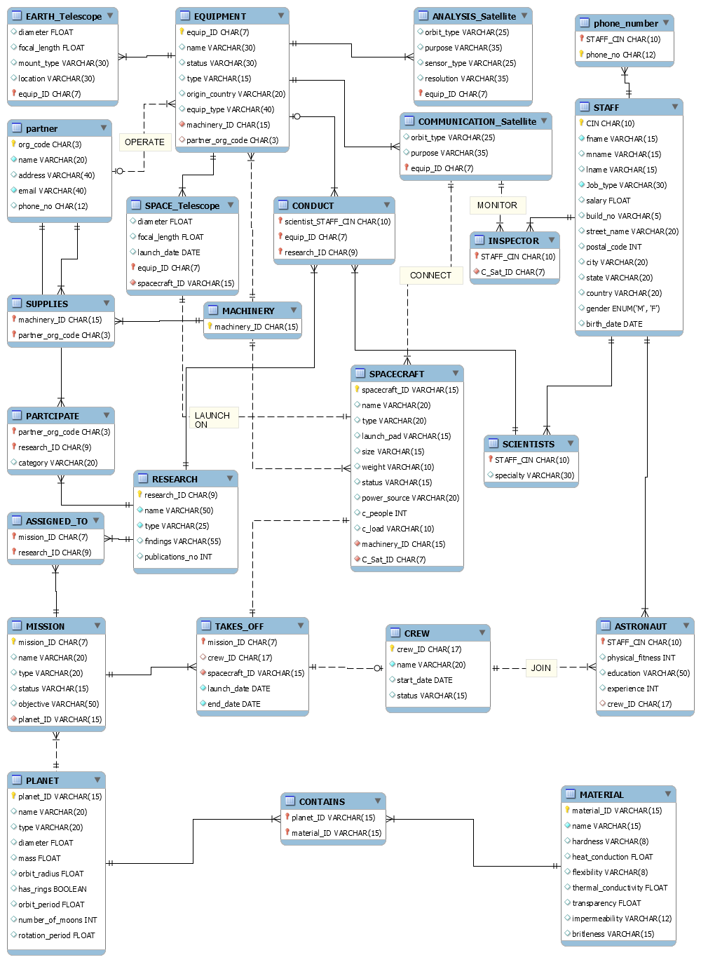

SQL_QUERIES

